CS 321 PROJECT MILESTONE (2)

Object Oriented Programming
Term2-2024/2025
Section: 6F8
Project Title: Life Pulse Hospital


Name | ID
Fatima Al-Marri | 2230003833
Alin Al-Qahtany | 2230006206
Nazilah Al-Azmi | 2230000546
Asiya Saquib | 2230009065
Fatima Alzayer | 2230006541
Members of the group:

Supervised by: Dalal Aldowaihi
Submission Date: May 3, 2025
Table of Contents
• ER Diagram 4
• Database Schema 5
• Data Description 6
• Tables Filled with Data 7
• Application Interface Design 11
• Application Structure 26
• Classes Hierarchy 27

Life Pulse Hospital - Functional Table  Function / Application Aspect Classes Management Data Export/Import Professional Appearance Error Handling Data Access Tools and Techniques  Users log in (Admin, Doctor, Patient) ✓ ✓ ✓ ✓  Patients can book appointments ✓ ✓ ✓ ✓  Doctors can view their assigned patients ✓ ✓ ✓ ✓  Doctors can add medical prescriptions ✓ ✓ ✓ ✓ ✓  Patients can view medical records ✓ ✓ ✓ ✓  Patients can book medical tests ✓ ✓ ✓ ✓  Admins can add/edit/remove doctors and patients ✓ ✓ ✓ ✓ ✓  System checks doctor availability before confirming booking ✓ ✓ ✓  All user inputs are validated (dates, IDs, formats, etc.) ✓ ✓ ✓ | ✓ |  | ✓ | ✓ | ✓

ER-Design:

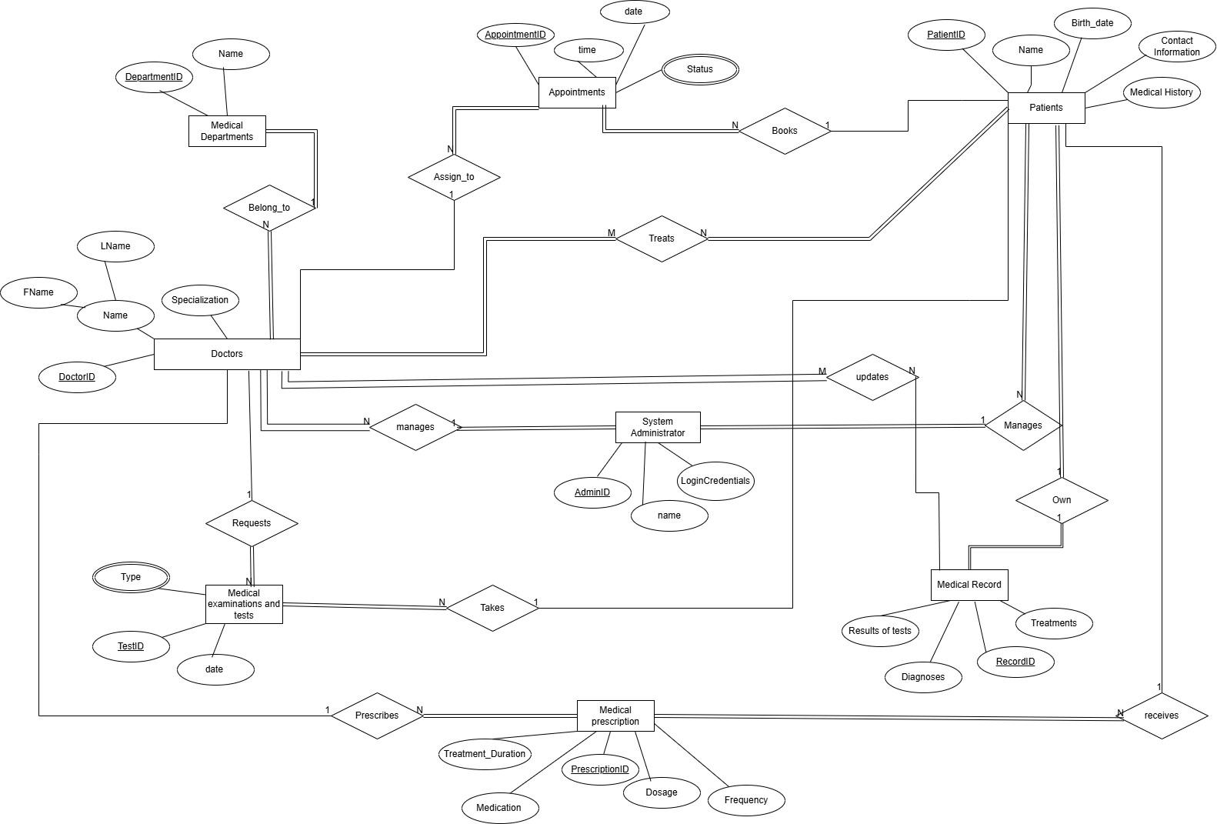

Database Schema:
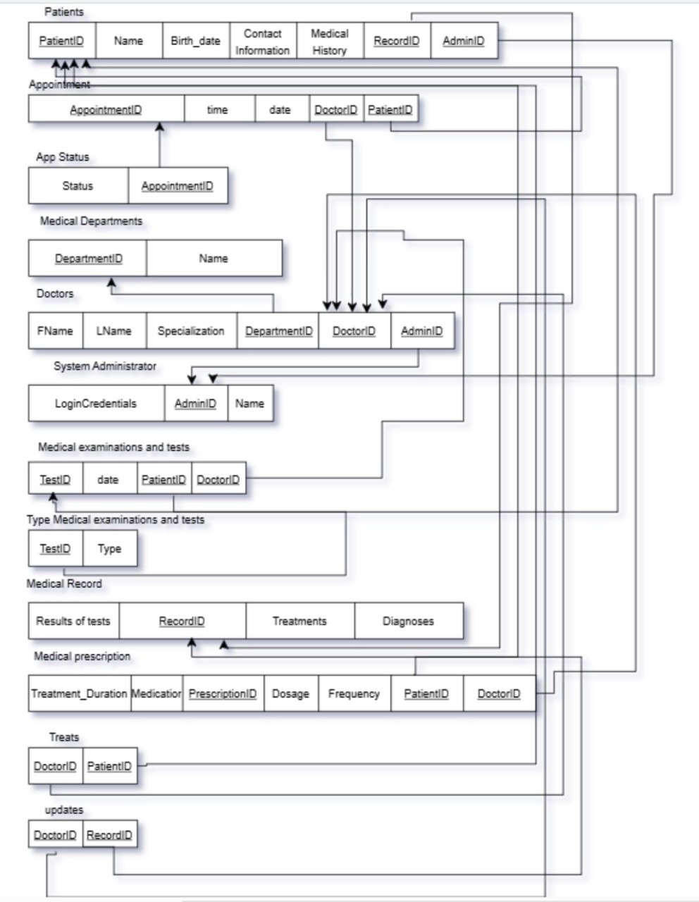

Tables filled with data:
Table 1:
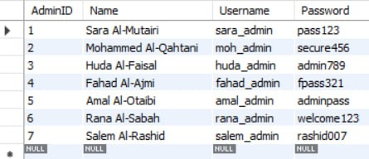

Table 2:
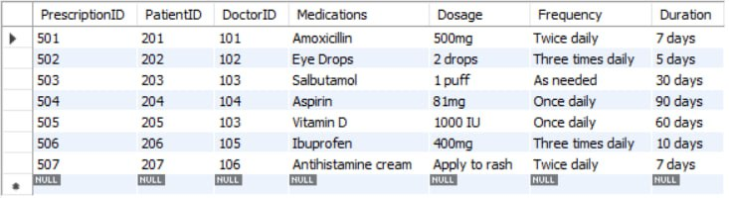

Table 3:
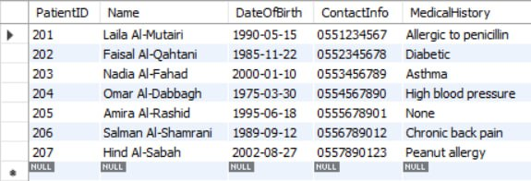

Table 4:
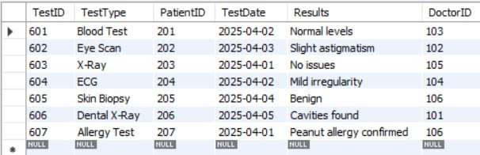

Table 5:
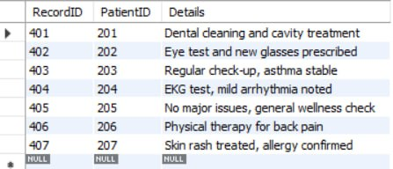

Table 6:
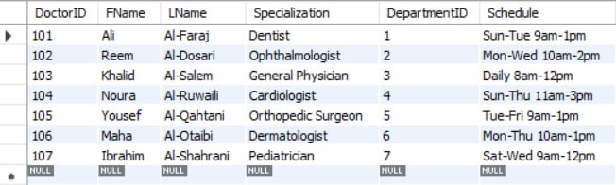

Table 7:
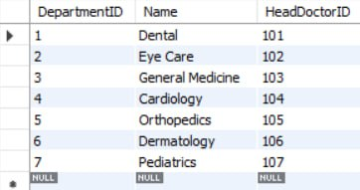

Table 8:
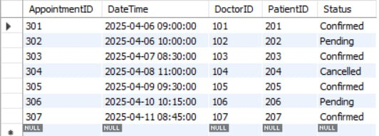

Table 9:
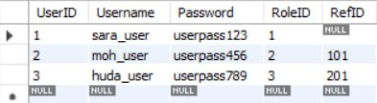

Table 10:
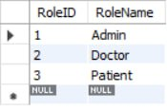

Application's Interface Design:



Home Page: The home page of the Life Pulse prominently displays the application’s name and logo, reflecting our commitment to high-quality healthcare. Life Pulse is a medical management system designed to streamline healthcare services. It provides patients, doctors, and admins with tools to efficiently handle their health-related needs. The interface includes a "Contact Us" button, allowing users to easily reach out for support or inquiries. To access services, users can either Log In to their existing accounts or Sign Up for a new account.

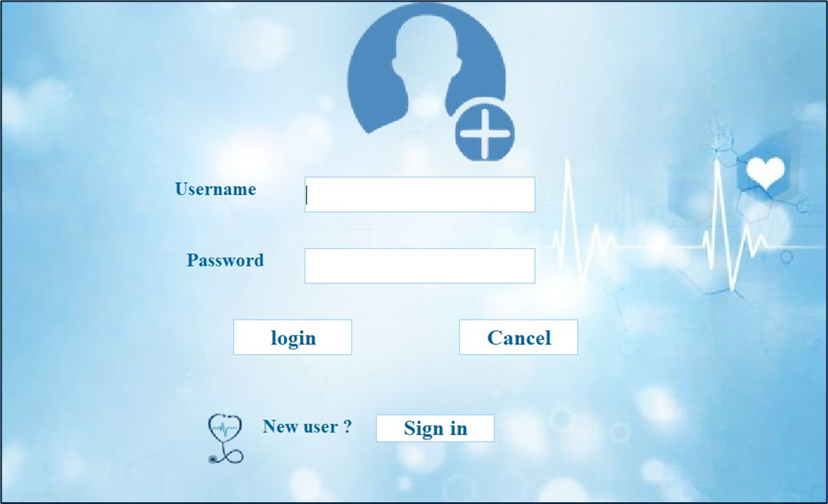

Login Page: The login page serves as a secure entry point for all users, requiring a valid username and password. If incorrect or unrecognized credentials are entered, the system immediately displays an appropriate error message to ensure account security.
Users have the option to either “Log In” or “Cancel” the process at any time. For new users, “Sign In” takes them to the sign-up page, where they can sign in by creating a new account.
This interface is designed to be simple and catering to various user types while ensuring a smooth and secure authentication process.

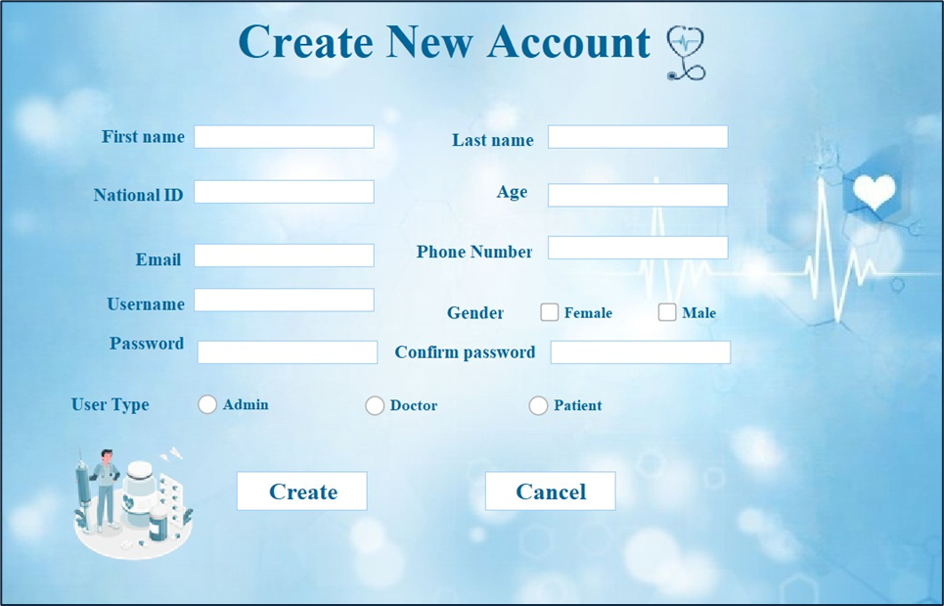
Create New Account: The sign-in page is specifically designed for users to open a new account by entering their personal information, including first name, last name, national ID, age, email, username, password, phone number, and gender, with enforced restrictions for valid entries. The “User type” selection allows users to choose between Admin, Doctor, or Patient roles. Once all details are entered, users can click "Create" to complete the registration process or “Cancel” to cancel the registration process.

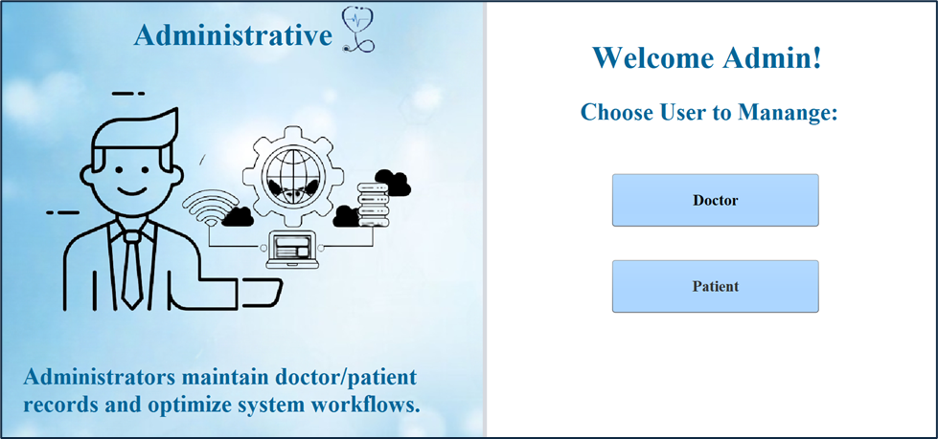

Administrative Interface: The Central Administrator Interface serves as the control panel for managing and overseeing both doctors and patients. From here, administrators can ensure smooth operations and efficient management of the system.

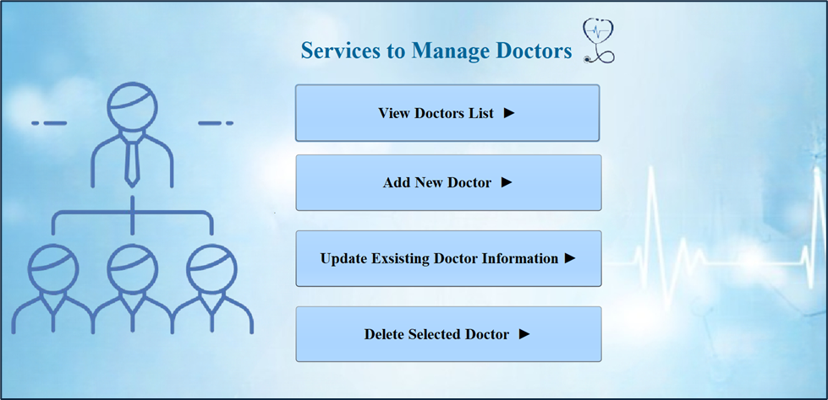
Services to Manage Doctors: The Doctor Management Interface allows administrators to efficiently view, add, update, and delete doctor profiles. This interface provides a centralized system to manage doctor records, ensuring that the most up-to-date information is always accessible.

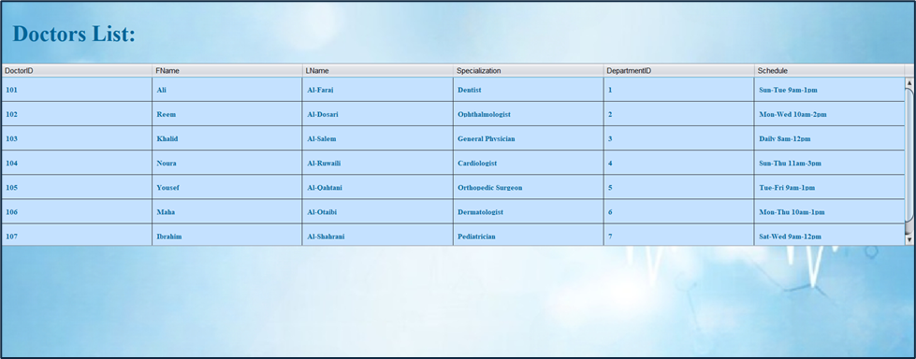
View Doctors List: A section where administrators can view the complete list of doctors in the system. The list displays important information such as the doctor’s ID, first and last name, specialization, department, and doctor's schedule.

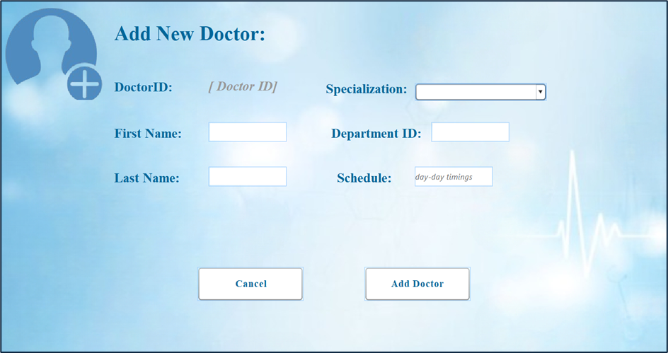
Add New Doctor: A feature that allows administrators to add a new doctor to the system by entering relevant details such as the doctor's first and last name, specialization, department, and schedule.The system automatically assigns an ID to each new entry. The administrator can click the "Add" button to confirm and save the changes or select the "Cancel" button to discard any modifications.
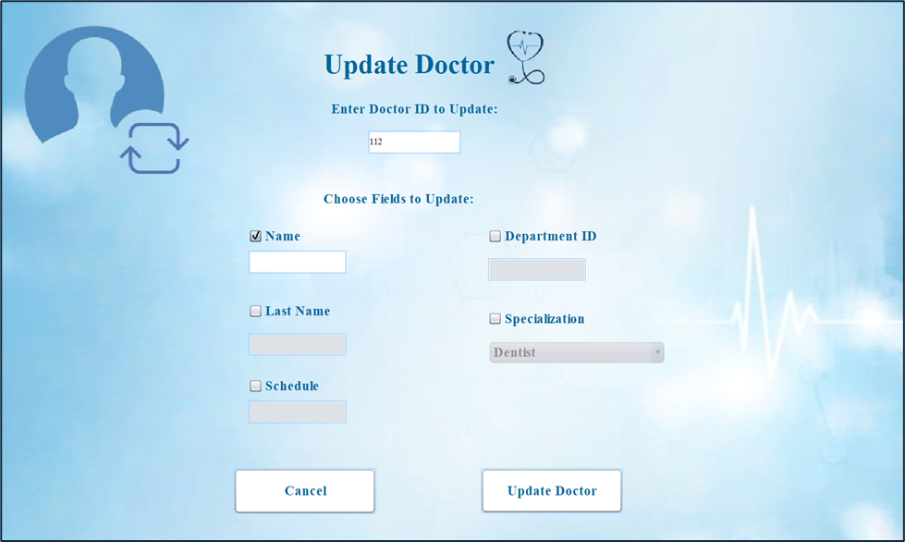
Update Doctor: The interface enables the admin to modify a doctor's details in the system. It prompts for the doctor's ID and allows the admin to select which fields need to be updated. Each field is accompanied by a checkbox, and the corresponding text field will remain disabled until the checkbox is checked. The admin can make the necessary updates and click the "Update" button to save the changes to the database or click "Cancel" to discard the updates.

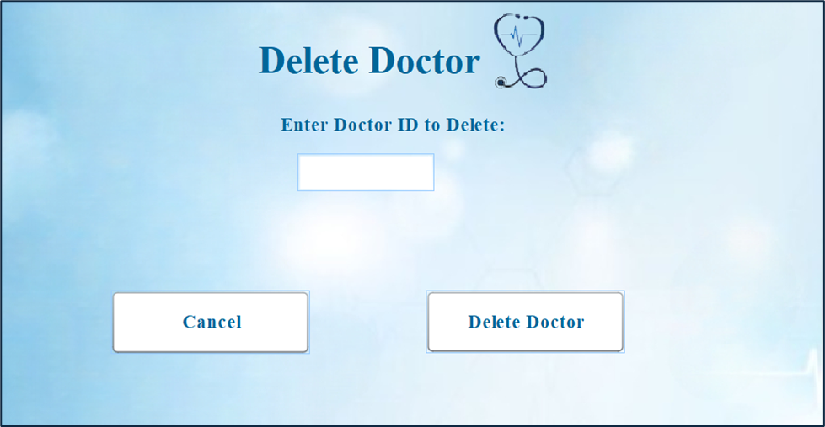

Delete Doctor: The interface prompts the administrator to enter the doctor's ID to identify which record needs to be deleted. After entering the ID, the admin can choose to either click the "Delete" button to confirm deletion or the "Cancel" button to discard the operation.

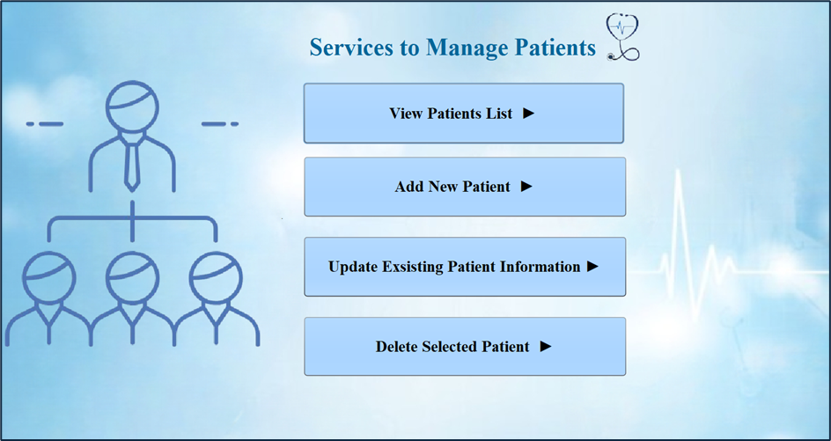
The same operations/services are applied to the patients as well by using the Services to Manage Patients Interface.

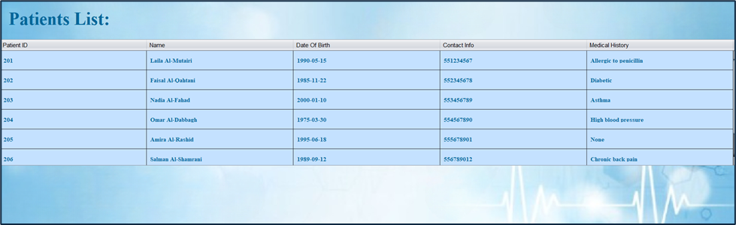
View Patients List: Administrators can view the complete list of patients in the system. The list displays important information such as the patient’s ID, name, DOB, contact info, and patient;s medical history.
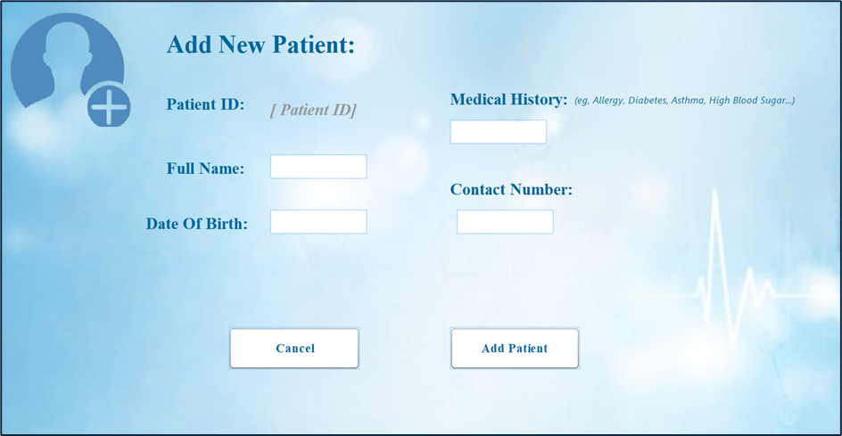
Add New Patient: A feature that allows administrators to add a new patient to the system by entering relevant details. The administrator can add or cancel the operation.
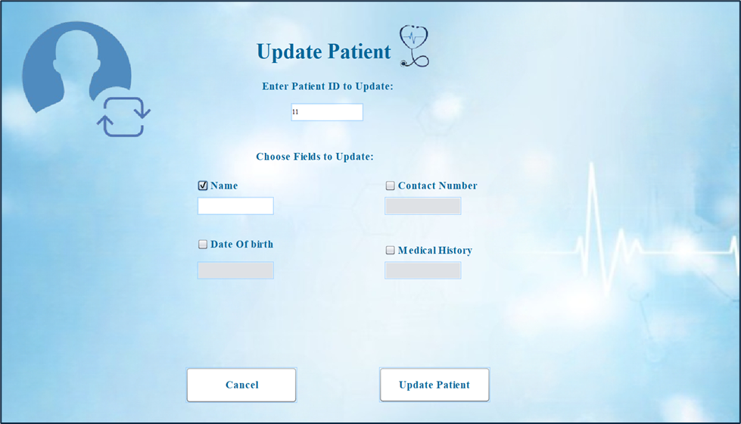
Update Patient: The interface enables the admin to modify a patient’s details in the system. It prompts the ID and allows the admin to select which fields need to be updated. Each field is accompanied by a checkbox, and the corresponding text field will remain disabled until the checkbox is checked. The admin can make updates or cancel to discard the updates.
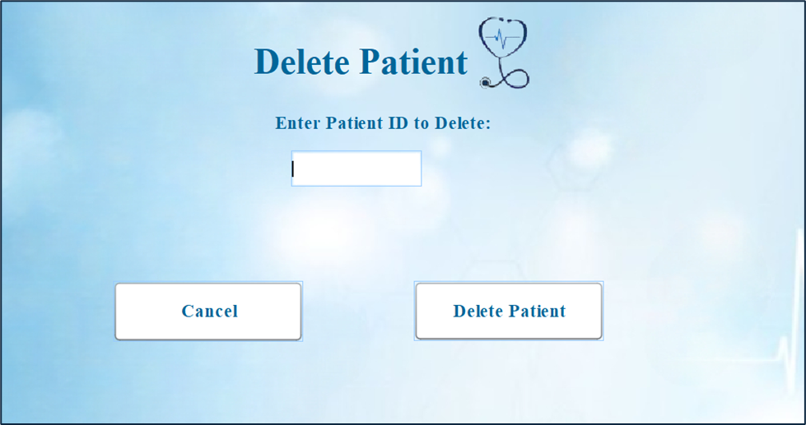
Delete Patient: The interface prompts the administrator to enter the patient’s ID for deletion. The admin can choose to either click the "Delete" button to confirm deletion or the "Cancel" button to discard the operation.

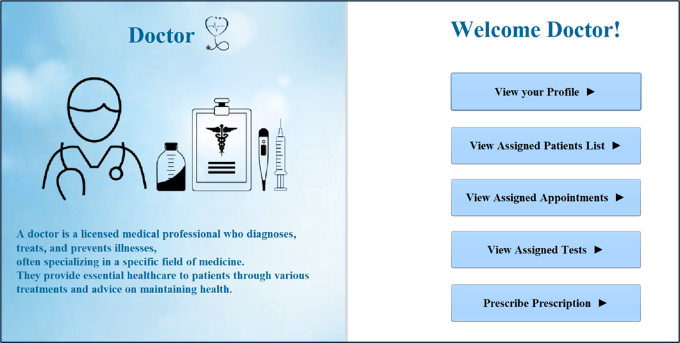
Doctor Interface: The main interface for doctors provides easy access to key features related to their practice. It includes options to view the doctor's profile, see a list of their assigned patients, upcoming appointments, assigned medical tests, and prescribe prescriptions. Each section is designed to help doctors efficiently manage their daily tasks and patient care.

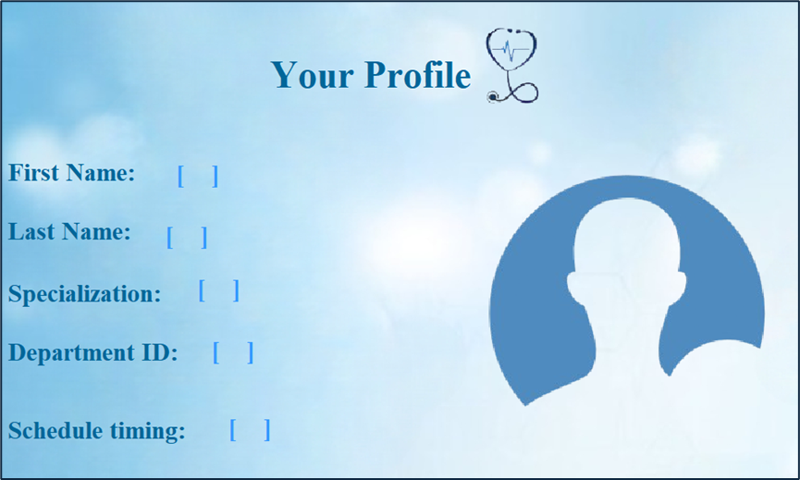
View Profile: This option allows the doctor to view their personal and professional information, such as name, specialization, department and their schedule timings.

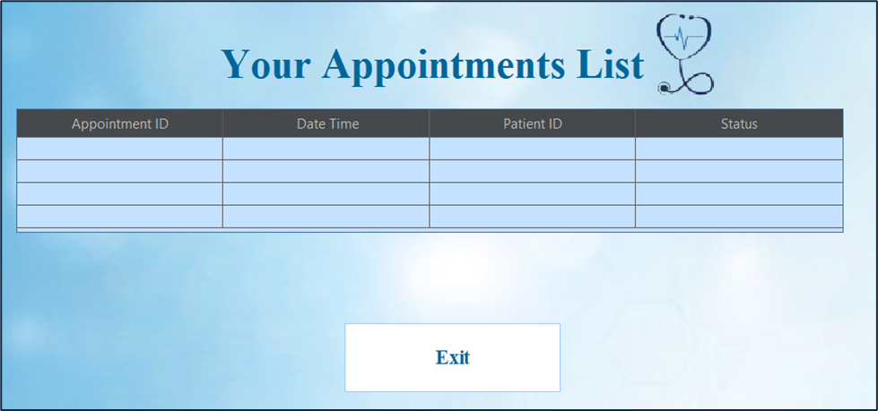
Appointments List: In this section, the doctor can view their upcoming appointments. It displays appointments info such as ID, date time, patient ID and the status of the appointment. It helps the doctors to stay organized by providing a clear overview of their schedule.
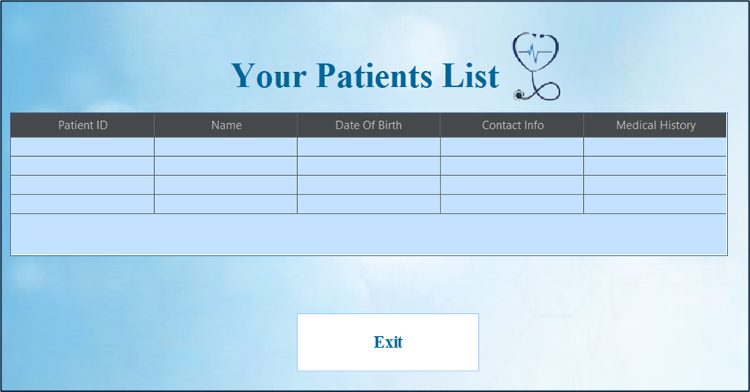
Assigned Patients List: This section displays a list of patients assigned to the doctor. The doctor can view detailed information about each patient, including their medical history. It helps the doctor keep track of their patient load and manage patient care effectively.

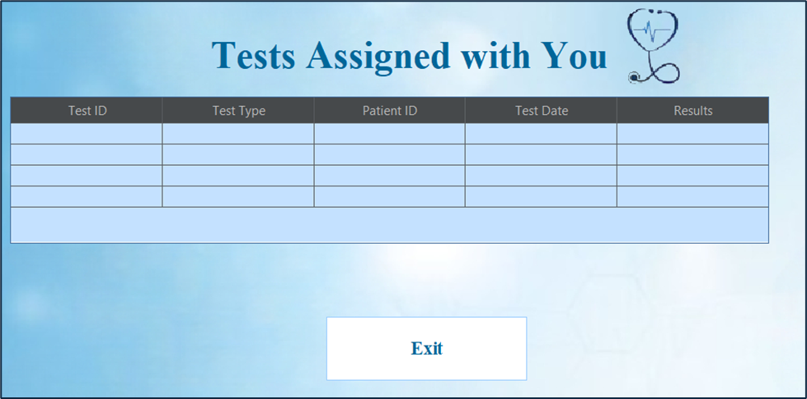
Assigned Tests List: This service allows the doctor to review medical tests that they have been assigned. It includes important details such as test ID, test type, patient ID, test date, and the results of the test. This feature helps doctors stay informed about the tests they need to review and follow up on.

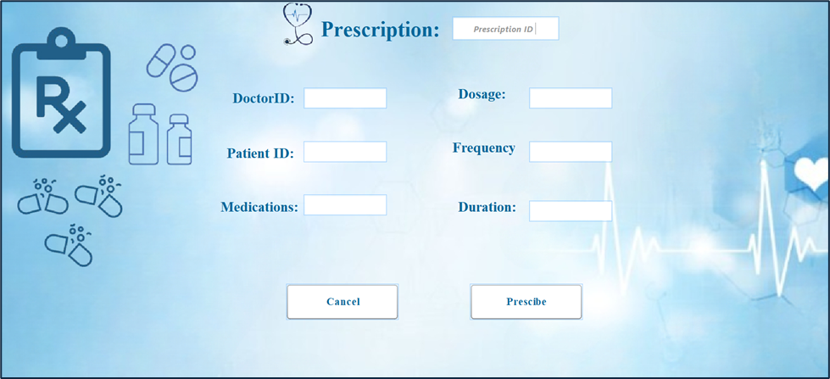
Prescribe Prescription: This option allows the doctor to prescribe medications to their patients. The doctor can create prescriptions that include the doctor and patient IDs, the required medications with their dosages, frequency, and duration. Once the prescription is created, the doctor can choose to prescribe it or cancel the process if needed.

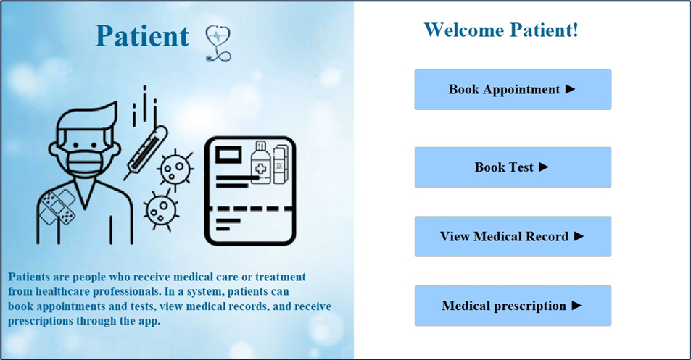
Patient Interface: This interface provides access to various services designed to ensure patient health and well-being. It includes options to book appointments, tests, view medical records and the prescription for the patient.
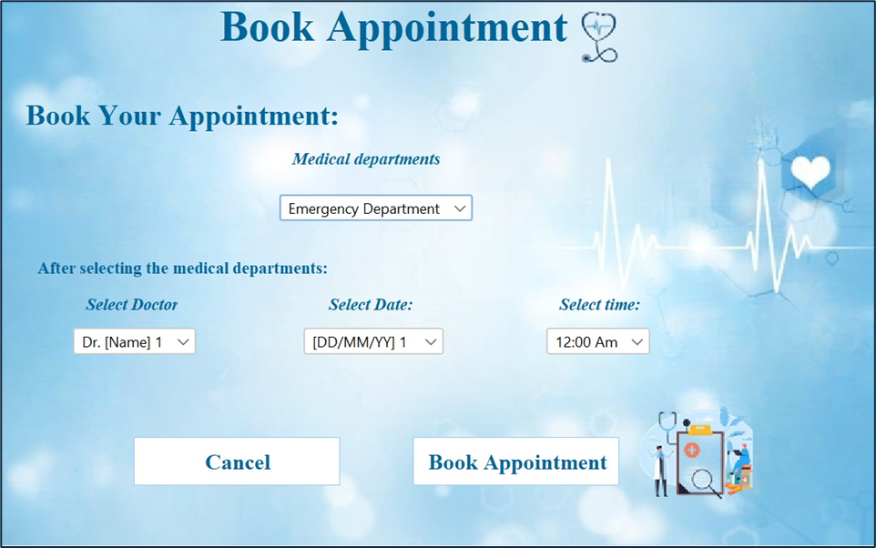
Book Appointment: This feature allows patients to easily schedule an appointment with a qualified doctor. The booking process begins with the patient selecting the medical department they need. Based on the selected department, a list of available doctors will be displayed. The patient can then choose a preferred doctor, select a suitable date and time, and click on "Book Appointment" to confirm the booking, or click "Cancel" if they decide not to proceed.
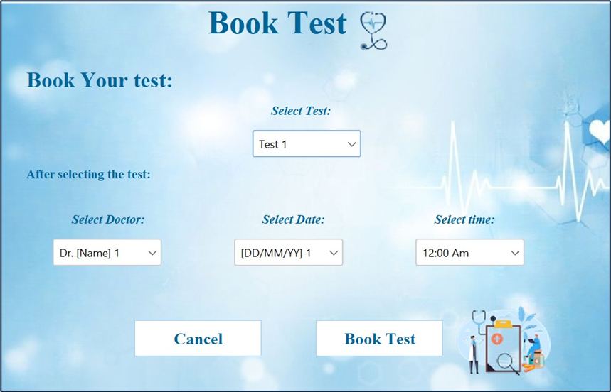
Book Test: This feature allows patients to schedule a medical test in a simple and convenient way. The process starts with selecting the medical department. Based on the chosen department, a list of doctors associated with that department will be shown. Patients can then select the test they need, choose the doctor who will oversee the test, and pick a suitable date and time. Once everything is selected, patients can click on "Book Test" to confirm the booking, or click "Cancel" if they decide not to proceed.

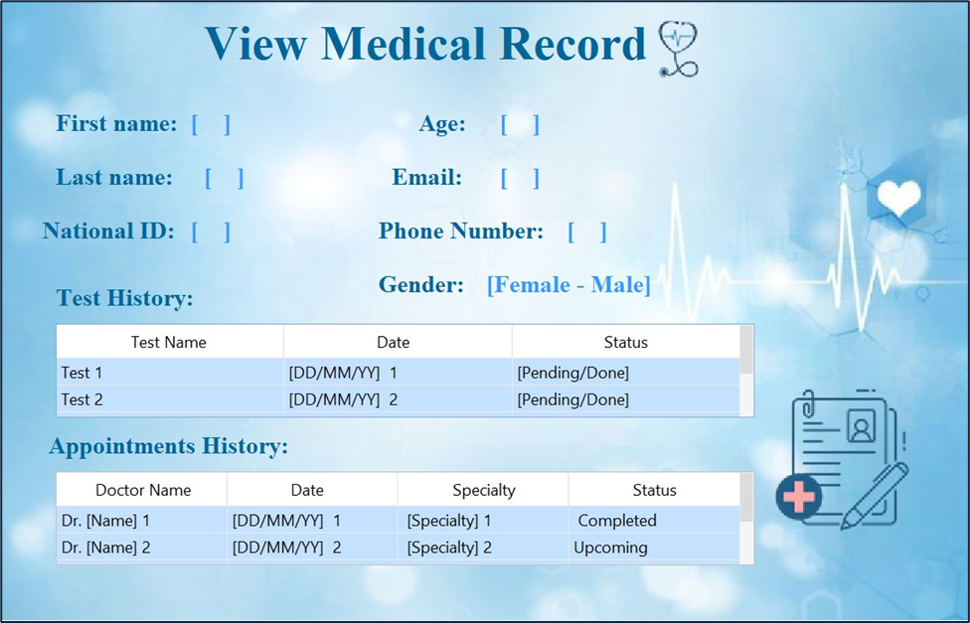
View Medical Record: This feature allows the patient to view their complete medical record. It provides detailed information including personal data such as first name, national ID, age, email, gender, and phone number. The record also includes a history of past appointments with doctor names, test history, and the status of appointments or tests. The system helps patients stay updated on their medical history and health progress.

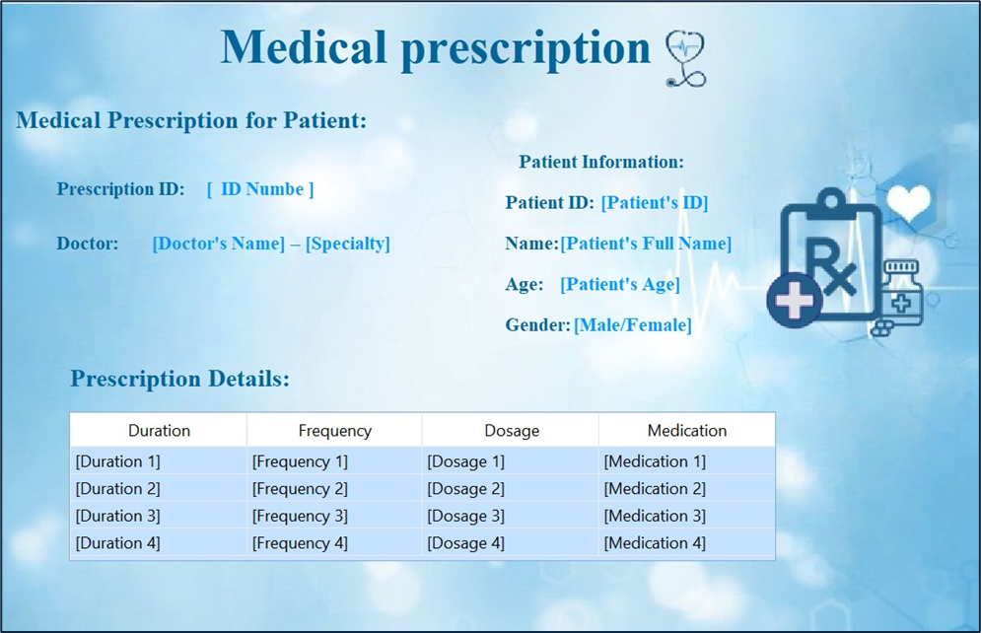
View Medical Prescription: This feature allows the patient to view their medical prescriptions. It displays the doctor's name and specialty, along with the prescription ID for easy reference. The patient’s information, such as patient ID, name, age, and gender, is also shown. The prescription details include the duration, frequency, dosage, and the prescribed medications to ensure clarity and proper usage. This section provides patients with all the necessary information related to their prescriptions for better understanding of their treatment.



Lastly, on the homepage, there is a "Contact Us" section located in the top-left corner. The "Contact Us" section provides the following contact information:
- Phone Number: 0122223333
- Instagram: Life Pulse_Hospital
- Twitter: @Life Pulse_Hospital
- Email: Life Pulse_Hospital@gmail.com
The user can easily access this information for assistance.

Application's structure:
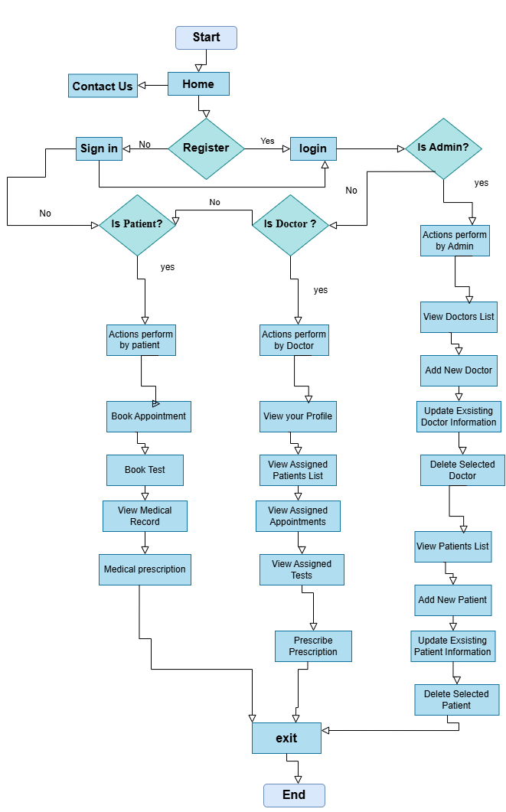

Classes' Hierarchy:
